Stereo Audio Amplifier

Nathan Paternoster

Jena Macias

**Description:**

We designed our stereo audio amplifier using the LM1877. The op-amp has feedback resistors Rf = 15k $Ω$ and input resistors Ri = 470 $Ω$. The left and right inputs are connected to the non-inverting terminals of the LM1877. The gain of each of the two non-inverting amps are therefore:

$$A_{v}=1+\frac{R_{f}}{R_{i}}=1+\frac{15k}{470}=+32.915$$

The op-amps are powered with a single voltage supply of +9V. The DC power supply has a *power-supply bypass capacitor* (CB) placed in parallel to remove any unwanted power-supply ripple voltage from appearing in the signal. A non-ideal DC voltage source will produce some small AC ripple that will introduce noise to the circuit. This capacitor will provide a path to ground for this AC ripple. The value of the capacitor will be 0.1 $μ$ F.

Two *coupling capacitors* (CI1 and CI2) are placed at the inputs. These will block the half-supply DC bias voltage (4.5V) from being fed back into the input (in this case our iPod). The values of these capacitors will be 0.1 $μ$ F. Likewise, two coupling capacitors (CO1 and CO2) will be placed at the output to prevent any DC voltage from appearing at the output. We are only interested in putting AC voltage to the output; the output coupling capacitors will block DC voltage from going to the speakers. The value of these capacitors will be large - 470 $μ$ F.

Normally an op-amp will contain some input offset voltage. This will be amplified at the output and produce noise. With very high gain, the DC offset voltages can cause the op-amp to exceed its rail voltages. There are two *DC stabilizing capacitors* (CDC1 and CDC2) placed at the inverting inputs of the op-amps. These will prevent the DC offsets from being amplified. With these caps the gain at DC will be unity and $1+\frac{R_{f}}{R_{i}}$ at all other frequencies. The value of these capacitors will be 10 $μ$ F.

*High-frequency compensation capacitors* (CHF1 and CHF2) are placed in parallel with the feedback resistor to remove high-frequency oscillations from occurring. These high-frequency oscillations occur when parasitic capacitance at the op-amp’s inputs combine with the feedback resistors. The HF compensations capacitors will provide a path for this capacitance so it won’t travel through the feedback resistors. The values for these capacitors will be small – 22pF.

To further improve the quality of the output audio signal we included two “snubber” circuits – one at each op-amp’s output. The snubber circuit consists of a path to ground that includes a resistor and a capacitor. Its purpose is to prevent any additional high-frequency oscillations (squeals) from appearing at the output. It basically acts as a low-pass filter at the output – removing higher frequencies from being put to the speakers. Both the resistor and capacitor will be small values – our resistors (RSN1 and RSN2) are 10 $Ω$ and the capacitors (CSN1 and CSN2) 0.1 $μ$ F.

*Input impedance resistors* will be put at the input to set the input impedance of the op-amp to a non-infinite value. They will also ground the op-amp’s input when no external input is connected so that the circuit’s inputs won’t be floating. They will be set to very large (but finite values). Our input impedance resistors (RM1 and RM2) will be 1M $Ω$.

Finally, our load will be a set of 4 $Ω$ speakers.

**Circuit:**

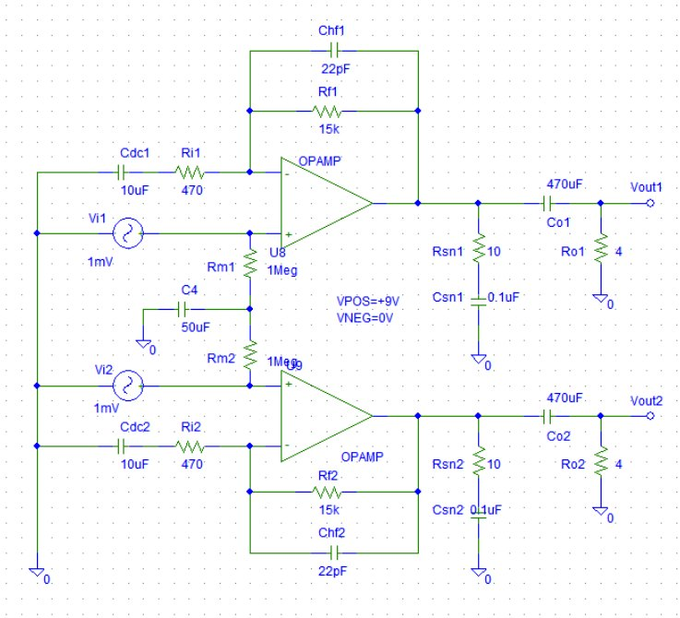

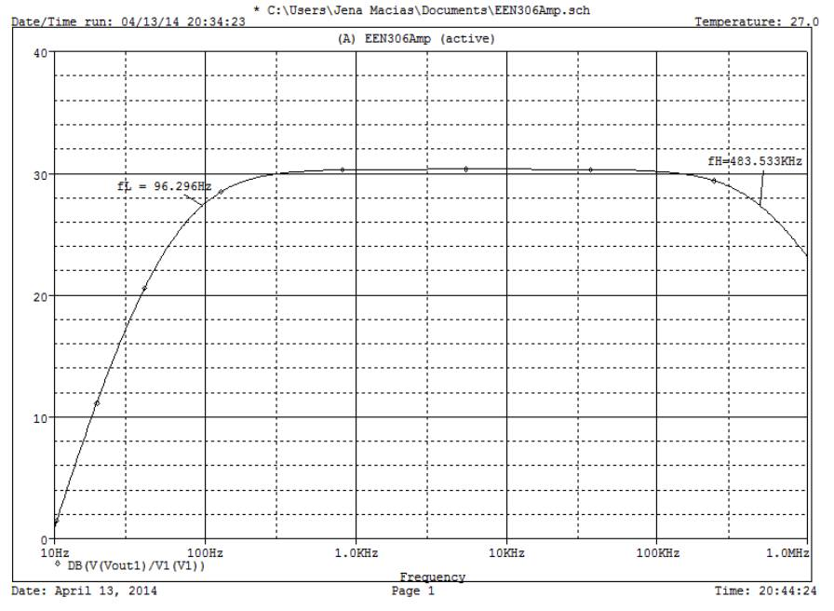**Simulation:**

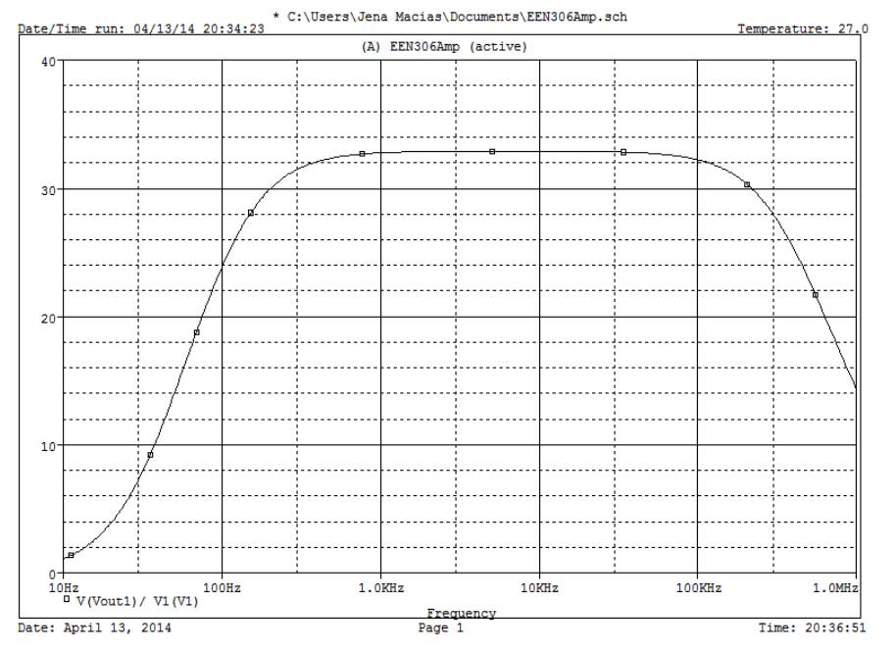

**Pictures:**

